Chapter 16, Problem 10.

The step responses of a series RLC circuit are

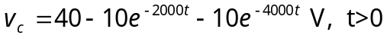
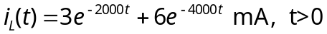

- Find C.
- Determine what type of damping is exhibited by the circuit.

